|  |  |
| --- | --- |
|  | |
| **ALL 1921: COA – Notification of Changes into Agency Forecast Screen**  **Functional Specification** | |
| Department: CMA CGM Commercial Allocation  Project: *DATAWAYS*  JIRA ID: ALL-1921  Author(s): *Infosys* | |
| **Doc Reference:**  **Date:**  **Version:**  **Status:** | ALL-1921 COA – Notification of Changes into Agency Forecast Screen  05.09.24  1.0  Draft To Be Reviewed |
| Classification: **Internal** | |

REVISIONS

|  |  |  |  |
| --- | --- | --- | --- |
| **Version** | **Date** | **Author** | **Subject** |
| 1.0 | 05-Sep-24 | Tushar Sharma | Document creation |
|  |  |  |  |

**REVIEWS**

|  |  |  |  |  |  |
| --- | --- | --- | --- | --- | --- |
| **Name** | **Title** | **Version** | **Date** | **Company** | **Signature** |
| Prabhu SESHADRI | IT Domain Lead | 1.0 |  | CMA CGM | Prabhu SESHADRI |
| HIENG Laurent | Product Owner | 1.0 |  | CMA CGM | HIENG Laurent |

APPROVALS

|  |  |  |  |  |  |
| --- | --- | --- | --- | --- | --- |
| **Name** | **Title** | **Version** | **Date** | **Company** | **Signature** |
| HOELLARD Damien | Lead Product Owner | 1.0 |  | CMA CGM | HOELLARD Damien |
| HIENG Laurent | Product Owner | 1.0 |  | CMA CGM | HIENG Laurent |

DISTRIBUTION LIST

|  |  |  |  |  |
| --- | --- | --- | --- | --- |
| **Name** | **Title** | **Company** | **To** | **Cc** |
| HOELLARD Damien | Lead Product Owner | CMA CGM | X |  |
| Prabhu SESHADRI | IT Domain Lead | CMA CGM | X |  |
| HIENG Laurent | Product Owner | CMA CGM | x |  |
| Veronique JOUSSELLIN | IT Domain Owner | CMA CGM |  | X |
| Julien D’ELIA | Enterprise Architect | CMA CGM |  | X |
| Youssef ATIK | Solution Architect | CMA CGM |  | X |
| Rudy MACARONUS | Chief Architect | CMA CGM |  | X |
| Victor BONY | Project Manager | CMA CGM |  | X |
| Ganesh IYER | Proxy Product Owner | Infosys |  | X |
| Ellina GALCHENKO | Product SME | Infosys |  | X |
| Akshita AHUJA | Product SME | Infosys |  | X |
| Dinesh Maurya | Product SME | Infosys |  | X |
| Savli TAPRE | Product SME | Infosys |  | X |
| Aishwarya RAJAN | UX Team | Infosys |  | X |
| Steffi SOLANKI | UX Team | Infosys |  | X |
| Abhishek KUMAR | Product SME | Infosys |  | X |
| Ben PAUL | Product SME | Infosys |  | X |
| Tushar Sharma | Product SME | Infosys |  | X |
| Tameshwar SAHU | Solution Architect | Infosys |  | X |
| Tapas SARKAR | Solution Architect | Infosys |  | X |
| Bala Chami | Scrum Master | Infosys |  | X |
| Sinchu PANICKER | PMO | Infosys |  | X |

CONTENTS

1 - Requirements 5

**1.1** Document References 5

**1.2** New or Modified Objects 5

**1.3** Acronyms & Glossary 5

2 Detailed Design 6

**2.1** Business Context and Scope 6

**2.2** .Business Constraints or Assumptions 6

**2.3** Functional Solution Risk 6

**2.4** Requirement Details 6

**2.5** Process Flow and Domain Entities 6

**2.6** UI / UX Design 7

**2.7** Validation and Rules 14

**2.8** Setups and configurations 15

**2.9** Processing definition 15

**2.10** Functional Test Cases 28

3 - Technical Details (Optional) 28

# - Requirements

|  |  |
| --- | --- |
| **Requirement ID** | **User Story / Requirement Description** |
| ALL-1921 | ALL-1921 COA – Notification Of COA changes into Agency Forecast Screen |

## 

### Document References

|  |  |  |  |  |
| --- | --- | --- | --- | --- |
| **Reference** | **Description** | **Version** | **Date** | **Author** |
| ALL-140 | My Scope of Services | JIRA | NA | Savli Tapre |
| ALL-46 | COA - Manually Publish COA Template to Voyage (Screen) | JIRA | NA | Kumar Abhishek |
| ALL 1133 | Consume COA by Bookings [Rules for Commercial Bookings] | JIRA | NA | Kumar Abhishek |
| ALL-127 | COA – Calculating available COA [Back End] | JIRA | NA | Dinesh Maurya |
| ALL-139 | Roles and Authorization | JIRA | NA | Ellina Galchenko |

### New or Modified Objects

|  |  |
| --- | --- |
| **Components involved and purpose (Part of technical Document)** | |
| N/A | N/A |

### Acronyms & Glossary

|  |  |  |
| --- | --- | --- |
| **Term** | **Acronym** | **Definition** |
| Booking Consumption | Booking Consumption | It is the consumption of TEUs, Tons and no. of units that is captured under each booking. |
| Laden Container Bookings | Laden Container | Laden container bookings refer to reservations made for shipping containers that are already filled with cargo. These containers are ready to be loaded onto a vessel for transport by sea. |
| Paying Empty bookings | Paying Empty | These are in a way commercial bookings wherein movement done for an empty container also generates revenue for the carrier. In those bookings, container is owned by shipper and not by carrier. |
| Dangerous Goods | DG | A dangerous good (also known as hazardous material or hazmat) is any substance or material capable of posing an unreasonable risk to health, safety, and property when transported in commerce |
| Out of Gauge | OOG | Cargo that cannot be loaded on a dry container due to its dimensions (height, width, and length) or weight is called Out Of Gauge (OOG) cargo. This type of cargo is transported on a open top container or flat rack container |
| Break Bulk | BB | Break bulk is the system of transporting goods in pieces separately, rather than being shipped in a container. Goods shipped in crates, bags, boxes, drums, barrels without the use of container are referred to as break bulk cargoes |
| Refrigerated Containers | Reefer | Refrigerated containers, also called reefer containers, are used for goods that need to be temperature controlled during shipping. Reefer containers are equipped with a refrigeration unit connected to the power supply on board the ship. |

# Detailed Design

### Business Context and Scope

The document describes the development of a COA target changes screen within the Forecast Per Voyage Screen. This new feature will allow Agency Trade users to see the adjustments made by Cargo Flow users at the COA Voyage Target level for each specific voyage.

### .Business Constraints or Assumptions

 Assumption is that allocation check is up-to date and synchronized as per business needs to access and display right information on the list of existing COA templates.

***Disclaimer: User must be having required authorization and access to the Cargo Flow Portal. (covered in user story ALL-139 COA-Roles and Authorization)***

### Functional Solution Risk

N/A

### Requirement Details

The user should be able to access Cargo Flow and navigate to the Forecast per Voyage screen. Upon entering, they will find two tabs: Forecast and COA Target Changes. The Forecast dashboard will be the default view. To view the COA target changes, the user will need to switch to the COA Target Changes tab. This screen will display any modifications or omissions made by other users in the COA template for the specific voyage. The COA Changes screen will retrieve and store these changes from the COA Template at the Voyage Level and present them in a clear format.

### Process Flow and Domain Entities

N/A

### UI / UX Design

**Mockup on Figma:** <https://www.figma.com/design/xy8DT97bl6eT0aOZUqAnsY/DATAWAYS-COA?node-id=10959-312108&node-type=canvas&t=L9ihIwF1YAhUYbcw-0>

1. **COA Target Changes Main Screen**: The main screen which would be available to user on the Forecast Per Voyage screen of COA Target Changes .The default screen is forecast but the user can click **upon COA Target Changes** tab to view the screen

1. **Omitting Level at COA Template at Voyage Level**: “**Allocation Deleted”** will be visible as new value to user if the user deletes the level in COA Template at Voyage level for a specified **CVN**

1. **Modifications in the COA Template at Voyage Level**

4) **COA Target Changes History**

The user can click on button “COA Target Changes History “ to view the history table

**The COA Target Changes History pop up screen will have horizontal and vertical scrollable functionality**

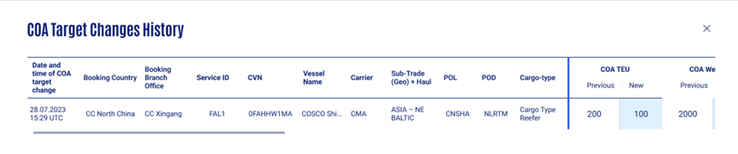

**COA Target Changes History Table as a pop-up screen**

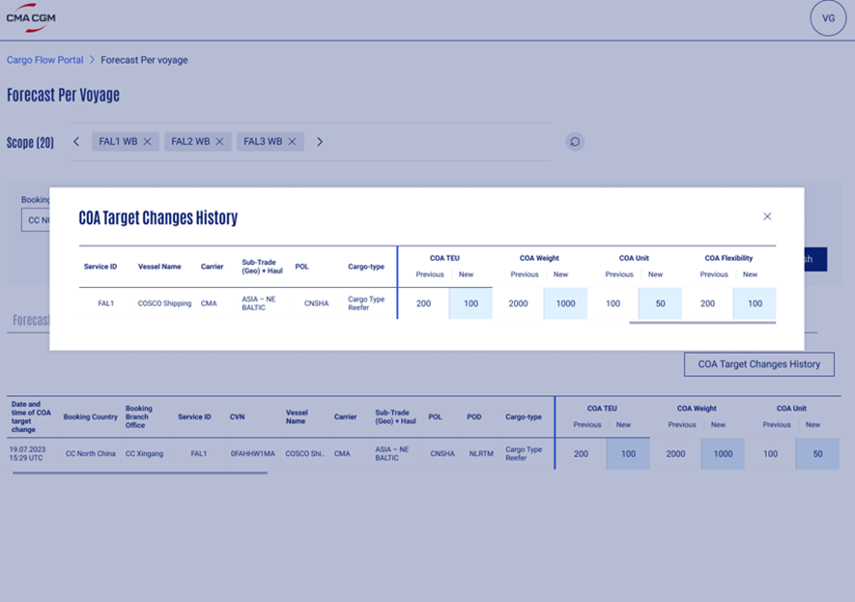

**COA Target Changes History Table as a pop-up screen continued**

### Validation and Rules

Below are the detailed definitions for attributes, buttons, and error messages in search & display and editing boundary templates.

|  |  |  |  |  |  |  |  |
| --- | --- | --- | --- | --- | --- | --- | --- |
| **SR** | **Label or Fields** | **Description** | **F** | **A** | **D** | **List** | **Rules** |
| 1 | POL | Port of Loading to be selected by the user | FA | M | E |  |  |
| 2 | Cargo Type | Cargo Type to be selected by the user | LOV | M | E |  |  |
| 3 | Clear All | This button to be clicked by the user to discard any changes made within the table | BT |  | E |  |  |
| 4 | Apply | This button to be clicked by the user to apply to view the booking consumption the table. | BT |  | E |  |  |
| 5 | Alloc TEU | Maximum TEU to be added by the user | FN | O | E |  |  |
| 6 | Alloc TONS | Maximum weight (in tons) to be added by the user | FN | O | E D |  |  |
| 7 | Alloc Unit(s) | Maximum allowed units to be added by the user | FN | O | E |  |  |
| 9 | Booking Country | Saved Booking Countries to appear in the list | CB | M | E |  |  |
| 10 | Booking Branch Office | Booking Branch Office pertaining to countries to appear in the list | CB | O | E |  |  |
| 11 | Time Range | Calendar to be displayed week-wise.  Maximum Selection Allowed  Upper limit- Current Day  Lower Limit – Past Three Weeks | CB | O | E |  |  |
| 12 | Proceed | Button to proceed with selection | BT | M | E |  |  |
| 13 | Apply and Refresh | Button to apply changes or apply the bookmark to view allocation screen | BT | M | E |  |  |

**Legend**

|  |  |  |  |  |  |  |  |  |
| --- | --- | --- | --- | --- | --- | --- | --- | --- |
| Format | CB | Check Box | Attribute | M | Mandatory | Display | D | Field disabled |
| FA | Field alpha | O | Optional | E | Field Enabled |
| FN | Field numeric |  |  | R | Read Only |
| LOV | List of Value |  |  | H | Hidden |
| DA | Date |  |  |  |  |
| BT | Button |  |  |  |  |
| DT | Date Time |  |  |  |  |

### Setups and configurations

N/A

### Processing definition

Following business rules must be implemented:

|  |  |  |
| --- | --- | --- |
| **ALL- 1921** | | |
| **ALL-1921: COA – Notification of COA changes into Agency Forecast** | | |
| **BR01** | **COA Target Changes Screen**  The Forecast Per Voyage screen shows two tabs: Forecast and COA Target Changes. The Forecast tab is the default view, providing detailed information about the voyage forecast. To access the COA Target Changes tab, the user can simply hover over the tab name and click on COA Target Changes.  The COA Target Changes tab displays all modifications made to the COA at the voyage level. Any changes implemented in the COA at Voyage Level screen will be reflected here, providing a comprehensive overview of the adjustments to the voyage plan | |
| **BR02** | **Omitting Level in a COA Template at Voyage Level**  On COA at Voyage Level , if the cargo flow user has omitted a particular level or deleted a particular level ,the user will able to see the Allocated Deleted as the new value in the COA Target Changes screen as depicted below.  For e.g. In case a user wants to remove Cargo Type Reefer from the allocation hierarchy structure.  The level CMA -> ASIA – NE BALTIC > CNSHA > Cargo Type Reefer is removed from the allocation hierarchy, then the COA Target Changes will have the “allocation deleted”   |  |  |  |  |  |  |  |  |  |  |  |  |  |  |  |  |  |  | | --- | --- | --- | --- | --- | --- | --- | --- | --- | --- | --- | --- | --- | --- | --- | --- | --- | --- | | Date and Times  Of COA  Change | Booking Country | Booking Branch Office | Service ID | CVN | Vessel Name | Carrier | Sub-Trade (Geo) + Haul | POL | Cargo Type | COA TEU Previous Value | COA TEU New Value | COA Weight Previous Value | COA Weight New Value | COA Unit Previous Value | COA Unit New Value | COA Flexibility Previous Value | COA Flexibility New Value | | 19.07.2023 15:29 UTC | CC North China | CC Xingang | FAL1 | 0FAHHW1MA | COSCO Shipping | CMA | ASIA – NE BALTIC | CNSHA | Cargo Type Reefer | 200 | Allocation Deleted | 2000 | Allocation Deleted | 100 | Allocation Deleted | Open | Allocation Deleted |   The COA Target Changes tab records all modifications made to the COA at the Voyage level, including deletions. In the case of the deleted allocation with Booking Country, Booking Branch Office , Service ID, CVN and Vessel Name , the following changes were captured:   * **COA TEU New Value:** Allocated Deleted * **COA Weight New Value:** Allocated Deleted * **COA Unit New Value:** Allocated Deleted * **COA Flexibility New Value:** Allocated Deleted   Prior to the deletion on **19.07.2023 15:29 UTC**, the allocation had the following values:   * **COA TEU Previous Value:** -200 * **COA Weight Previous Value:** -200 * **COA Unit Previous Value: 100** * **COA Flexibility Previous Value:** OPEN   The COA Target Changes tab captures this event with a timestamp, providing a historical record of the allocation's status."  **Date and Times Of COA Change-**This field will capture the Time stapmp of the event of modification or deletion in the COA Template at Voyage Level  **COA Target Changes with Deleted Level – Cargo Type Reefer**  **Validations of Flexibility**  The previous value can both have Open and numeric flexibility values.  The new value can both have Open and numeric flexibility values .  Range of Flexibility (in case of restricted and non opencoa) -0-500%    **Deleting Allocation Value at Parent level in COA at Voyage Level**  In the case where the user has deleted allocations at parent level in COA at Voyage Level , the COA Target Changes screen will capture all the child levels associated with the parent level on the COA Target Changes .The logs will include the allocation deleted at each child level .  For example ,consider a scenario ,where we have the following Allocation Structure for a CVN at COA at Voyage Level    **Allocation Structure for the CVN at COA Voyage Level**  The deleting of the allocation for this structure when the user deletes the allocation at Carrier Level CMA will be depicted in the following way on the COA Target Changes Screen.    In the current scenario ,the user has deleted the Carrier -CMA at the given time as showcased in the screen.On the COA Target Changes screen we will showcase the logs at each child level |
| **BR03** | **Modifications in COA at Voyage Level**  The Agent Forecast user will be able to view modifications made by other users to the COA at the voyage level. The displayed information includes the **Date and Time of the COA Change**(time stamp of omitting or modifying the level), **Booking Country**, **Booking Branch Office**, **Service ID**, **CVN**, **Vessel Name**, **Carrier**, **Sub Trade (Geo) + Haul**, **POL**, and **Cargo Type**.  To provide a comprehensive overview of the modifications, the following fields are also displayed:   * **COA TEU**: Previous TEU Value and New TEU Value * **COA Weight**: Previous COA Weight Value and New COA Weight Value * **COA Unit**: Previous COA Value and New COA Value * **COA Flexibility**: Previous COA Flexibility Value and New COA Flexibility Value"     **Multiple Changes in the same allocation structure**  Consider a scenario where the user has modified the same allocation values multiples ,here in the scenario the allocations of CMA -> ASIA – NE BALTIC > CNSHA > Cargo Type Reefer were changed at COA at Voyage level at two different times .We will capture the logs of the changes equal to the times the changes have been imparted in the allocation values at COA Voyage Level | |
| **BR04** | **Alert(s) Expiry**  Alerts visible in the COA Target Changes tab will be retained for 7 days from the date of the event occurrence. After this period, the alerts will be moved to a history table for further reference.  **Time Range Filter**  The time range should be set at default to the current day as the upper limit to the last 7 days as the lower limit in the time range, if the user has not selected any value in the time range box. The maximum time range on the lower limit is last 3 weeks from the current day | |
| **BR05** | **History Table**  The COA Target Changes History table provides a record of all COA target changes that have expired from the main COA Target Changes screen. This history table retains expired data for an additional 14 days.  For example, if a data field expires on the 7th day in the main COA Target Changes screen, it will become available in the history table on the 8th day. This data will remain accessible in the history table for 14 days further. After the 14th day, the data will be permanently removed from both the main screen and the history table."  **Button – COA Target Changes History**    On clicking the COA Target Changes History button the user will be able to view the history table screen as pop-up showcasing the COA Target Changes expired data from 8th Day to 14th Day of event occurrence    **COA Target Changes History pop-up screen**  The COA Changes History will have both horizontal and vertical scrollable functionality. | |

### Functional Test Cases

|  |  |  |  |  |
| --- | --- | --- | --- | --- |
| **Test Case #** | **Rule** | **Functional Test** | | **Expected Results** |
| **ALL-1921: COA – Notification of COA changes into Agency Forecast Screen** | | | | |
| **TC01** |  | | Check whether all the elements on the Operational Restrictions screen matches with the UX/UI Mock-ups | Refer section 2.6 UX/UI Designs. |
| **TC02** | BR01 | | User clicks on the tab on COA Target Changes Screen | User can view COA Target Changes Screen |
| **TC03** | BR02 | | User deletes a child level from the allocation structure | User is able to view “Allocation Deleted” as New in COA Target Changes Screen |
| **TC04** | BR03 | | User A is editing the COA at Voyage Screen User changes allocation values in COA TEU ,COA Units ,COA Flexibility ,COA weight | User changed values are updated under the new status and previous values are also shared to user in COA Target Changes Screen |
| **TC06** | BR05 | | COA Target Changes Screen alerts on 8th day of event occurrence | The alerts are removed from COA Target changes screen and the alerts are visible on COA Target History Table |

# - Technical Details (Optional)

Technical solution will be done by architect and development teams.

- End of document –